
INFOST 440 Flex

Contact Information: Dee Piziak/piziak@uwm.edu

Instructions:

- Read Chapter 2 of the textbook.

- Read PowerPoint_4

- Read “Assessment4_Additional Information”

- In addition to the Chapter1 subfolder which you created in assessment 3, create another subfolder under PHP_Flex folder and name it Chapter 2. See screen shot below.

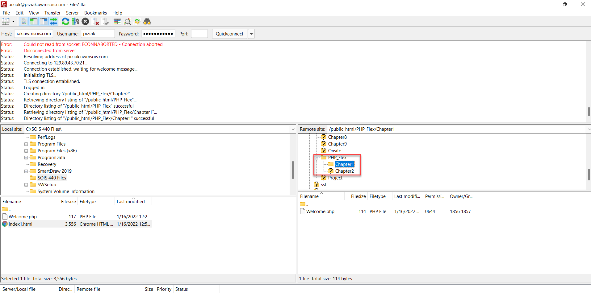

- Form1.html: Create an html form and write a PHP script that would handle the html form as follows:
- Create an html form that allows the user to input a number.
- Create a php script that would do the following:
  - If the number is <10, display the message “The number is smaller than 10”
  - If the number is between 10 and 100, display the message “The number is between 10 and 100”
  - If the number is >100, display the message “The number is larger than 100”
- Add a link to this form on your index page under the Chapter 2 section. Call it Form1.
- Your Form1.html should look like the form below:

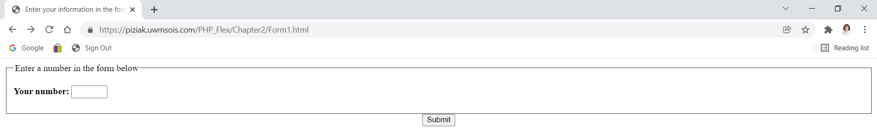

- Refer to the “Assessment4_Additional Information” file for more help on creating Form1

- Form2.html: Create another html form and write a PHP script that would handle this html form as follows:
- Create a form that allows the user to input two numbers.
- Create a php script that would do the following:
  - Check whether the two inputs are entered; if not, display an error message and stop.
  - Check whether both inputs are numeric; if not, display an error message and stop (Hint: There is a function that can do this).
  - Display the sum of the numbers.
- Add a link to this form on your index page in the Chapter 2 section. Call it Form2.
- Your Form2 should look like the form below

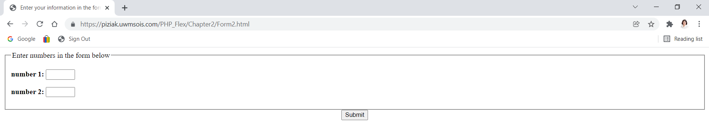

- Refer to “Assessment4_Additional Information” file for more help on creating Form2

- Your final Index.html file with links to Form1.html and Form2.html should look like

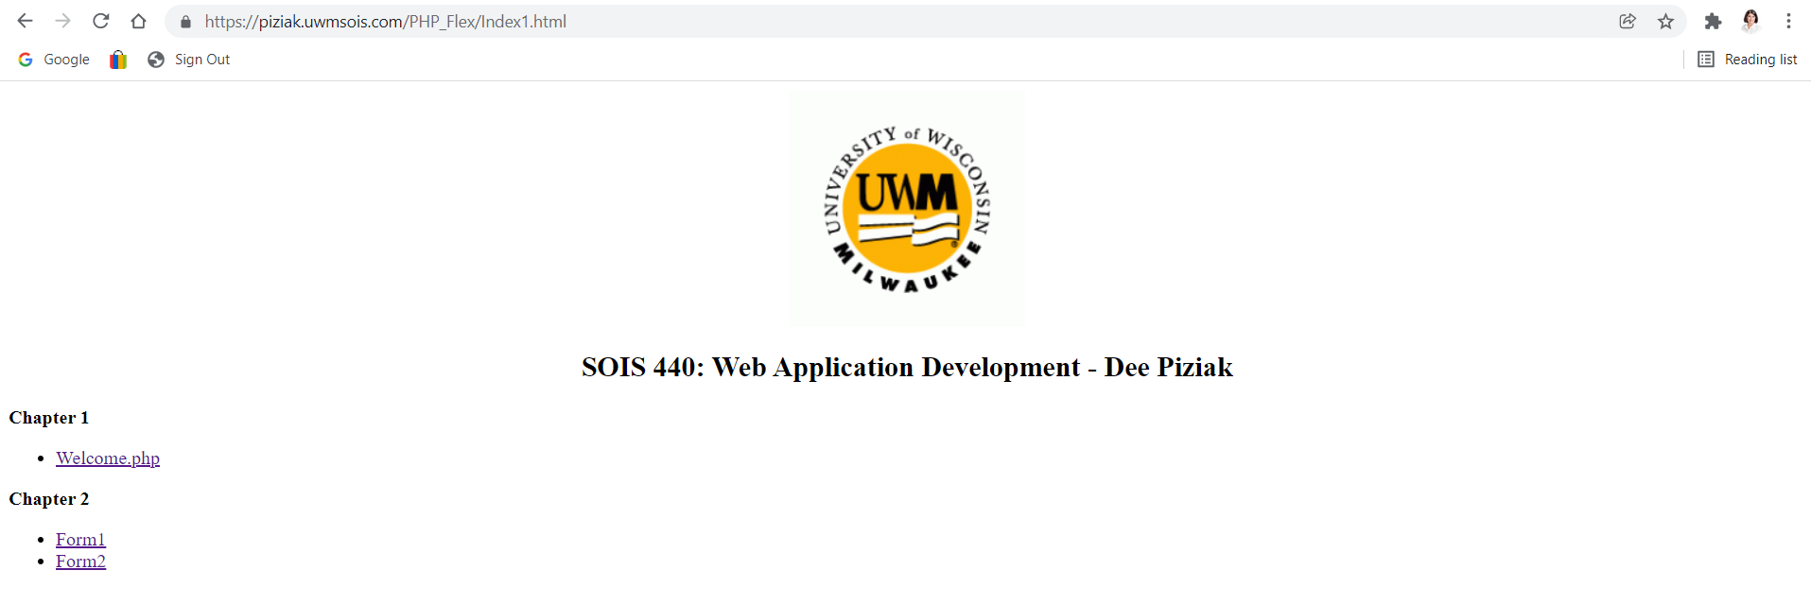

- Upload the following files to Assessment 4 drop box:
- A text file containing the URL to your index.html file as you did for Assessment 3 so I can test all the links under Chapters 1 and 2. Please remember to not change the location of your Index.html file and keep it under public_html \PHP_Flex as you had it in assessment3.
- Form1.html
- Form1.php
- Form2.html
- Form2.php

